Worksheet 6 Trees

Task 1
1. Annotate the tree below to identify the root, an edge, a parent, a child, a subtree and a leaf.
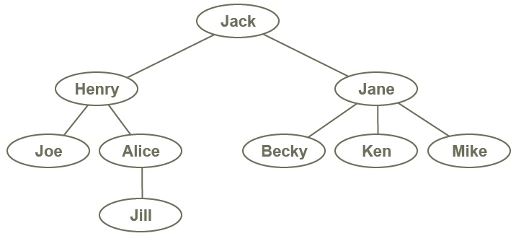
Jack = Root
Lines = Edge
Henry + down = Subtree
Jane = Parent/Child
All the little circle name thingies = Leaf

2. Grundy’s game is a game for two players which starts with a pile of coins. Players take it in turn to make a move; a legal move consists of splitting a pile into two piles of unequal sizes. Thus for example a pile of 8 coins could be split into two piles of (7, 1), (6, 2) or (5, 3). The next player can split either of the two piles, so that for 2 piles of (7, 1) there will be three options of (6, 1, 1), (5,2,1), (4,3,1), etc.
(a) Complete the tree below to represent all possible moves and outcomes in the game.
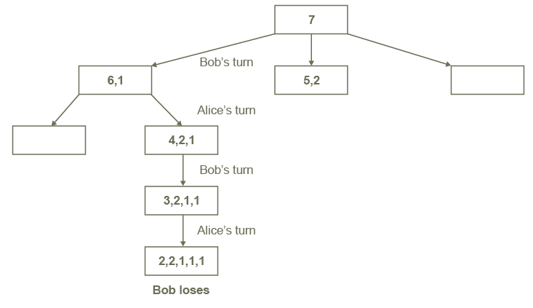

Alice’s turn
(b) If Bob has the first move, is there any strategy that he can adopt to make sure he wins? Is there a winning strategy for Alice?

Task 2

3. Here is a binary tree.

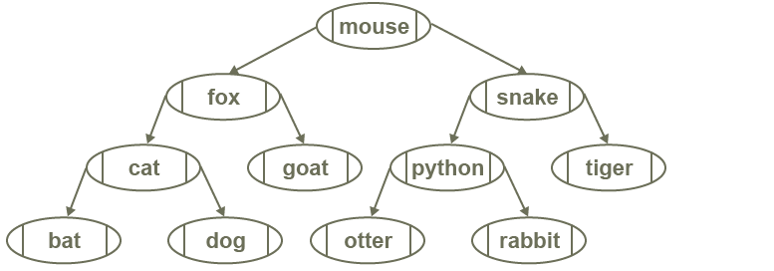

(a) Write down the order of the nodes visited in a pre-order traversal.

Mouse, fox, cat, bat, dog, goat, snake, python, otter, rabbit, tiger

(b) Write down the order of the nodes visited in an in-order traversal. What pattern do you notice about this traversal?
Bat, cat, dog, fox, goat, mouse, otter, python, rabbit, snake, tiger

(c) Write down the order of the nodes visited in a post-order traversal.
Bat, dog, cat, goat, fox, otter, rabbit, python, snake, tiger, mouse

4. Construct a binary search tree to hold the names Fred, Ken, George, Ray, Millie, Charlie, Ella, Tim, Amy, David

Task 3

5 ‘Binary Tree Task’ – Here is a binary tree.

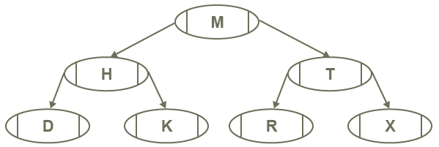

- Complete this array of records to represent this binary tree.

 | left | data | right
tree [0] | 1 | M | 2
tree[1] | 3 | H | 4
tree[2] | 5 | T | 6
tree[3] | -1 | D | -1
tree[4] | -1 | K | -1
tree[5] | -1 | R | -1
tree[6] | -1 | X | -1

